Binah Ndeh

Homework5

1. Configure File and print sharing on your Win10pro VM.

a. Create and share a folder called class24share on your win10pro

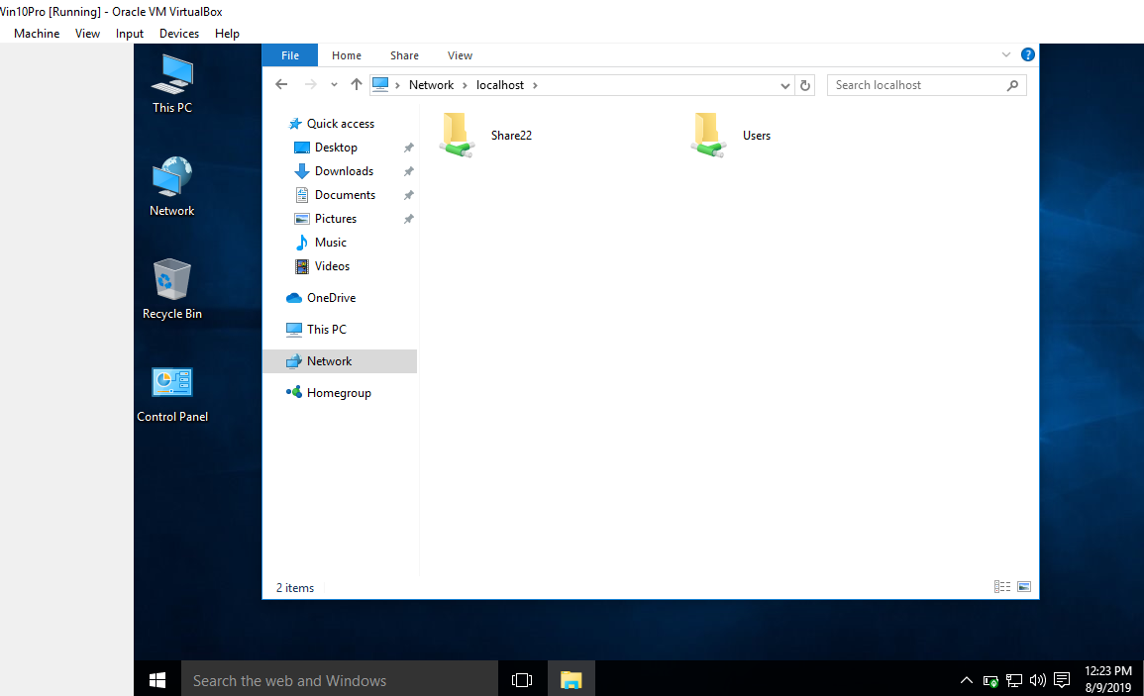

 b. Map a drive with drive letter M from your laptop to the share on your win10pro VM.

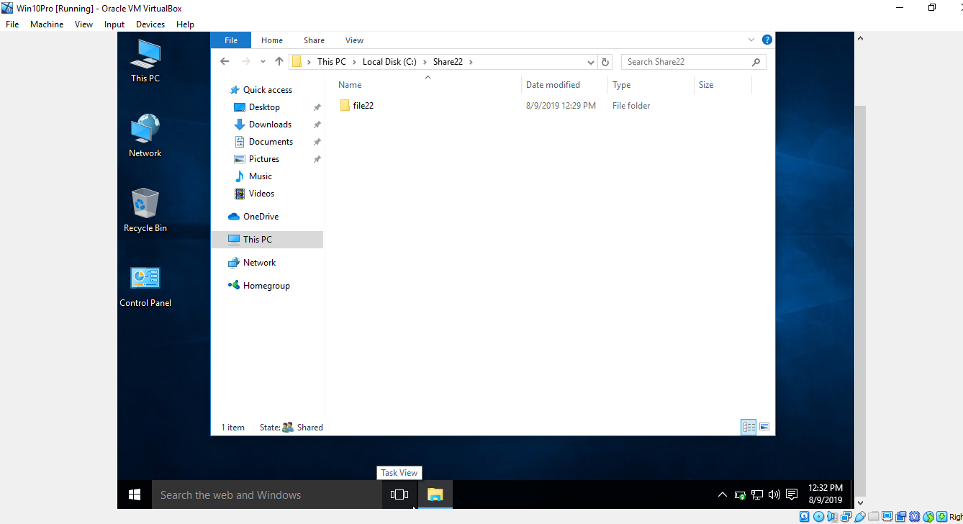

c. Transfer the file yourname24d from the Document folder from your laptop to your Win10pro via the M: Drive

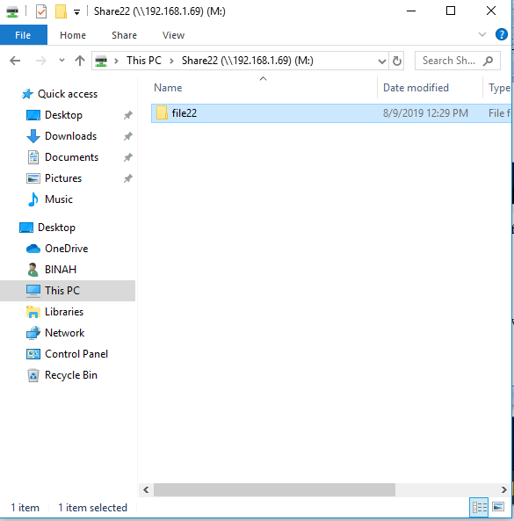

2. Watch the following video and Install your Windows 2008 Server

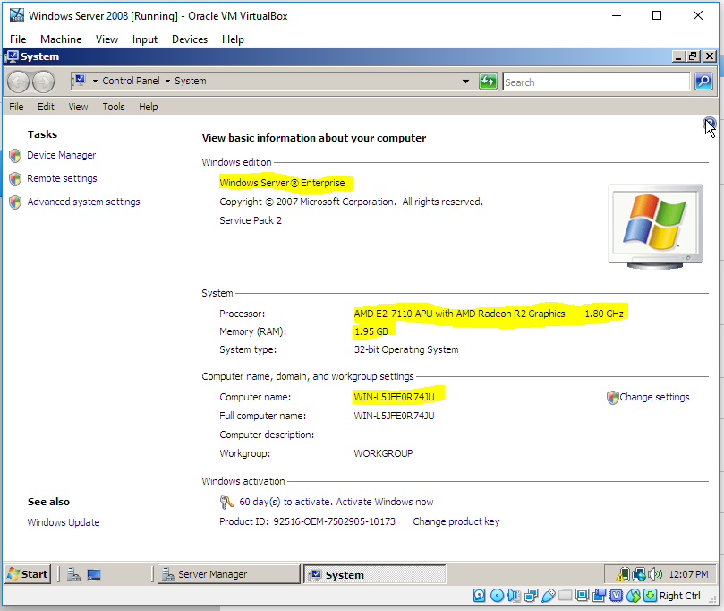

3. Download the Packet Tracer application attached to this homework.

Downloaded